Spooky Stitching September / October – 2024
The aim of this spooky stitching is to work on spooky / supernatural and other worldly projects throughout the month of September and October. The appeal for commencing this in September is the alliteration and a change from the traditional Sampler September. Noting that there are some cool spooky related samplers out there, that could easily fit into the Spooky September Stitching!

How it will work – Using the decision wheel app

Choosing what to stitch and listen to/watch
Utilising the decision wheel app (or something similar), create two to three wheels with different themes. Wheel one will have all of the projects you want to stitch throughout the spooky season.
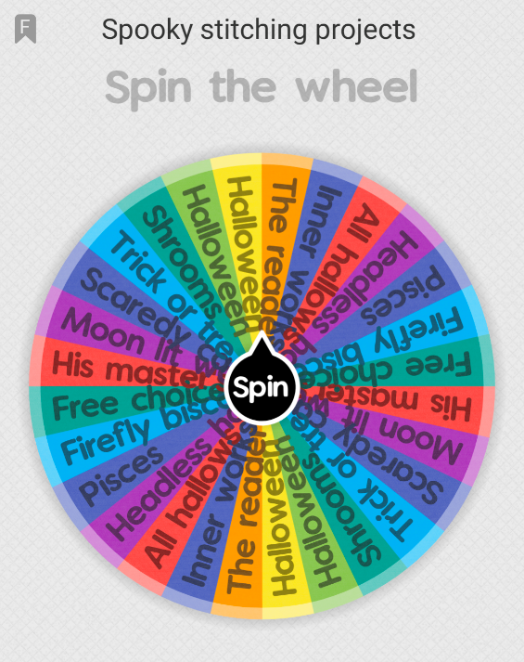
  - Wheel 1 – Spooky Stitching Projects
Project | Designer/Charted by…
Shrooms | Heaven and Earth Designs (HAED)
His Masters Voice Mini | HAED
Moonlit Waters | HAED
All Hallows Eve (New start) | Charting Creations
The Reader | HAED
Halloween Treats 1 | Tilton Crafts
Halloween Treats 2 | Tilton Crafts
Inner Works of Life | HAED
Firefly Biscornu (New start) | MM
Scaredy Cats | HAED
Pisces | Personal
Headless Horseman (New start) | To be determined
Trick or Treat 2 | HAED
Wheel two will have a variety of prompts related to the spooky season.
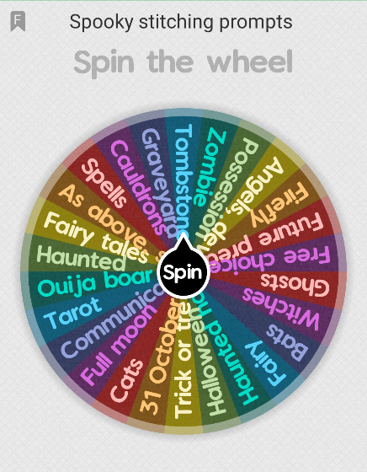
  - Wheel 2 – Spooky Stitching Prompts
Wheel three will have a variety of media options to have as background noise if you like to partly watch or listen to something while you’re stitching.
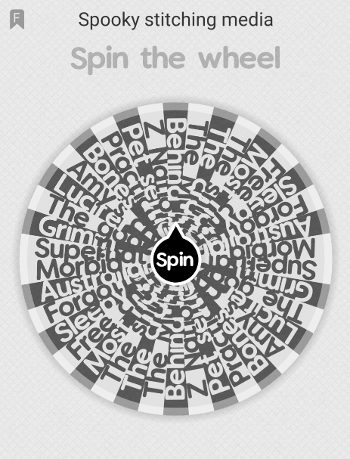
  - Wheel 3 – Spooky Stitching Media
Some of the media options on this wheel include (but not limited to):
Tv shows | Movies | Podcasts | YouTube
Supernatural | The Shining | Morbid | Amy’s Crypt
Grimm | Hocus Pocus | Two Girls, One Ghost | Beardo Gets Scared
Sleepy Hollow | Sleepy Hollow (Johnny Depp) | Australian True Crime | Ambiance
Bones | Practical Magic | Forgotten Australia
Behind Her Eyes | Pet Semetary

Free choice piece
An interesting option on all three wheels is to have a free choice piece. When this comes up, you get to choose what the prompt is, what you work on or what your background noise is. This could even mean you have a day off from stitching or treat yourself to a new project or stitch in silence!

Counting stitches vs timing
In place of any of these wheels, you could have one that determines how long you stitch for or how many stitches you need to get done during a set period of time. The choice is yours for what numbers and timeframes you put on the wheel.
Alternatively, if you’re super media focused like I am and enjoy having some form of background noise when stitching your timing piece could be stitching for as long as the movie, podcast episode, television show etc. goes for. Resulting in a project seeing love for a minimum of 30 minutes up to 2+ hours. At the end of each stitching session, you could note down how long you worked on that piece and the number of stitches completed during the session. You could also include time spent frogging and other types of stitches that were stitched as well (e.g. tent / half-stitch, back-stitch, French knots, specialty stitches etc.).

Alternates to decision wheels

Draw it out of a hat…
To change things up and have something tangible and get family and friends involved too, is to have all of your options on pieces of paper and draw them out of a hat, jar, container.

Family and friends choose for you
Similar to drawing it out of a hat, ask your friends and family to chose any of the options for you or all of them! This could even be the spooky version of March Madness where you take to social media and through a poll, ask people to decide what project you should work on.

Spooky Bingo
Similar to WIPGO or ABC-GO, you could have a table/spreadsheet setup like a Bingo board, and through the rolling of a dice or something similar, the numbers chosen will correlate to the projects you have on the board. When that number and project is chosen, you work on it for the amount of time or number of stitches you’ve allocated to that project.

Using the days of the month
Alternatively, you could have the board setup based on the calendar for September and October and each day or week, work on a project you want to see some progress on. Using the number of each day, e.g. first of September, could correlate to the amount of time or stitches you spend on that project. Below is an example of how the calendar could look:
September
Sunday | Monday | Tuesday | Wednesday | Thursday | Friday | Saturday
1 – Trick or Treat 2 = 1 hour | 2 – Shrooms = 200 stitches | 3 – His Master’s Voice = 300 stitches | 4 – Inner Works of Life | 5 – The Reader | 6 – Halloween Treats 2 | 7 – Halloween Treats 1
8 – All Hallows Eve = 80 stitches | 9 – Pisces = 90 minutes | 10 – Firefly Biscornu = 10 minutes | 11 – Scaredy Cats | 12 – Moonlit Waters | 13 – Headless Horseman | 14 – Free Choice
15 – Shrooms | 16 – Shrooms | 17 – Shrooms | 18 – Shrooms | 19 – Shrooms | 20 – Shrooms | 21 – Shrooms
22– The Reader | 23 – The Reader | 24– The Reader | 25– The Reader | 26– The Reader | 27– The Reader | 28– The Reader
29– Firefly Biscornu | 30– Firefly Biscornu = 30 minutes

